Preliminary summary of results of 2015 Karthala geophysical surveys
- Introduction
A magnetotelluric (MT) survey (80 stations) and a gravity survey (200 stations) were run on Mt Karthala (2400 masl) in July-August 2015 by Jacobs and GNS (two specialised geothermal consultancies based in New Zealand), with the goal of exploring the potential for energy extraction from the Karthala geothermal system, with a view to generate electricity. Both surveys were finished on August 2nd, 2015 and the data processing and interpretation is due for completion within the next 2 months. The modelling to date is only a ‘first look’ into the MT dataset, consequently all results presented here are preliminary.
The approximate locations of the stations acquired during these surveys are shown on the map below:
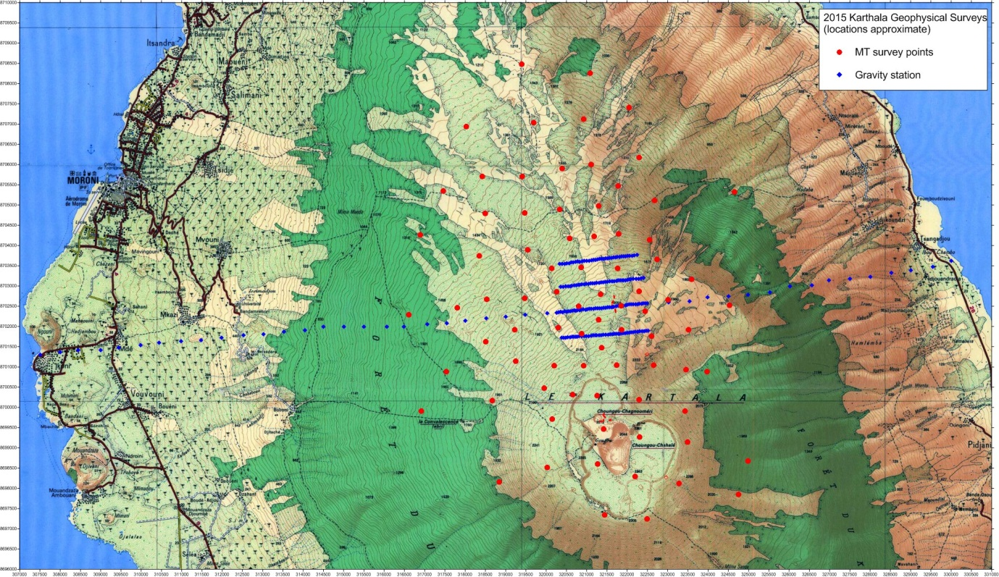
Figure 1 Map of 2015 Karthala geophysical surveys (MT in red, gravity in blue)
- Preliminary results
The data quality obtained during this survey was satisfactory for the purpose of assessing the geothermal potential with a large part of the dataset being of very good quality.
The geothermal system is likely to be associated with the NNW-trending rift structure extending from the north of the Karthala caldera towards the solfataras of La Soufriere and beyond.
A profile taken across the rift in the vicinity of the solfataras shows the presence of an electrically conductive zone with some relief, bordered to the east by a resistive zone (see Figure 2). A strong conductor (brightest red zone on Figure 3) is associated with the location of the solfataras themselves and the fumaroles inside the northern lobe of the Karthala crater. While along a north-south cross-section, a sporadic alignment of conductive zones is seen.
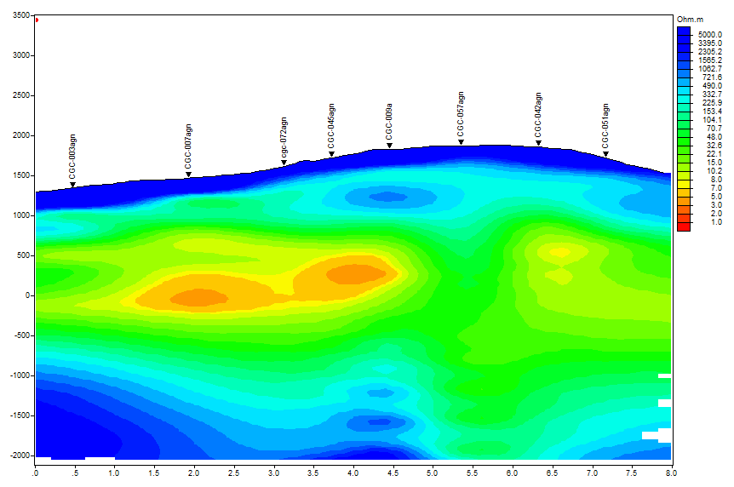
W E
Figure 2 West-East Profile across the rift showing the conductive zone (in red) and a resistive area just east of it likely associated with the rift (near station CGC-057).

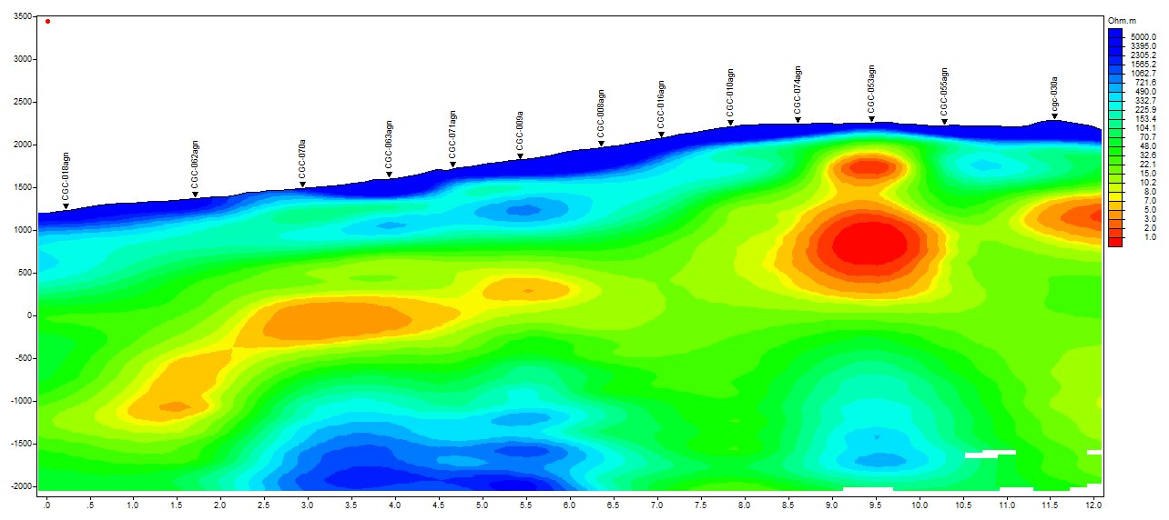
N S
Figure 3 Line of conductive zones (in red) suggesting a north-south conductive alignment, potentially narrow, a feature which will require the use of 3D inversion to be imaged more accurately.
The presence of these strong conductors in association with the thermal features of the solfataras and fumaroles is a positive indication of geothermal activity at depth; the particularly low resistivity values indicate the presence of hydrothermal alteration associated with these features. However, we do not as yet have a good understanding of the extent of these altered zones. This will be interpreted from the 3D resistivity model when it is available in September 2015.

